# 

**Natural Gas Price Variation Over time** **1**

**Analyzing Log Returns** **3**

**Daily Data Summary Statistics Analysis** **5**

**Weekly Data Summary Statistics Analysis** **6**

**Augmented Dickey-Fuller Test for Daily Data** **6**

**Augmented Dickey-Fuller Test for Weekly Data** **6**

**ARCH effects test for Daily Data** **7**

**ARCH effects test for Weekly Data** **7**

**GARCH model analysis for daily Data** **8**

Model Specification: 8

Coefficients: 8

Summary Statistics: 8

Error Analysis: 8

Model Convergence: 8

Interpretation: 8

**GARCH model analysis for weekly Data** **10**

Model Specification: 10

Coefficients: 10

Error Analysis: 10

Summary Statistics: 10

Optimal Parameters: 10

Robust Standard Errors: 11

Information Criteria: 11

Diagnostic Tests: 11

Interpretation: 12

**Garch modeling comparison - Weekly vs Daily** **13**

# 

# Natural Gas Price Variation Over time

This is the analysis of both weekly and daily data which shows an upward trend and daily data shows more variability than the weekly one.

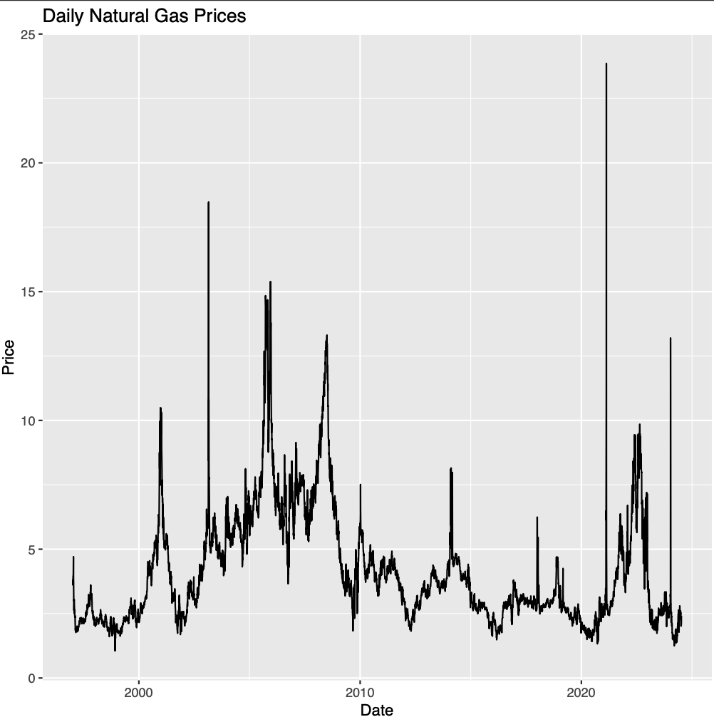

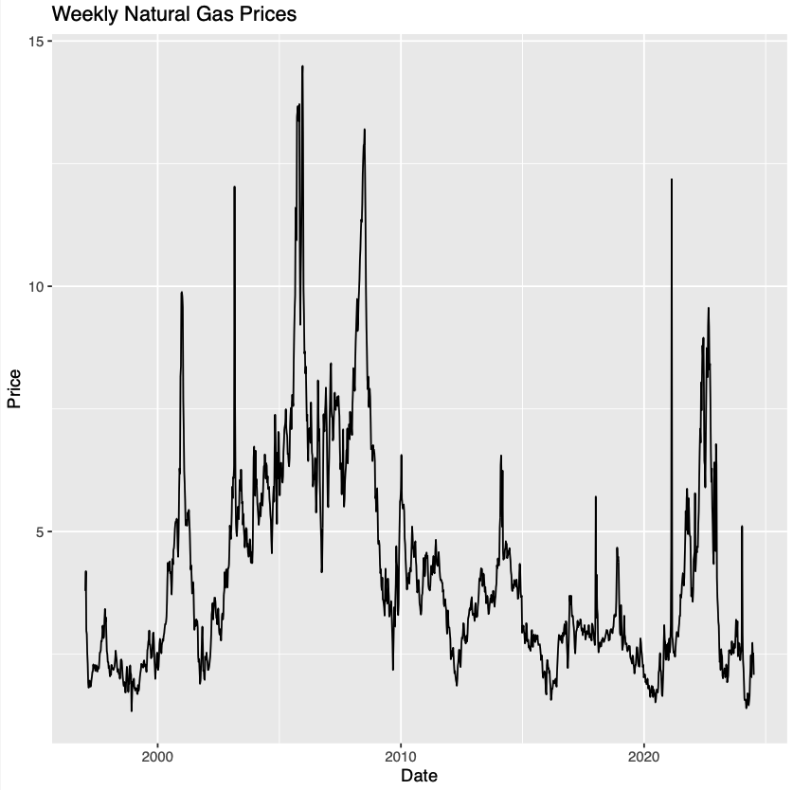

# Analyzing Log Returns

Analyzing natural gas prices with log returns offers several advantages. Firstly, it normalizes the data. This means large price swings don't overshadow smaller ones, allowing us to compare percentage changes across different time frames regardless of the starting price. Additionally, log returns make calculations for long-term growth or decline easier. Instead of multiplying multiple percentage changes, we can simply add the log returns of consecutive periods. Furthermore, log returns can help reduce autocorrelation, a phenomenon where past price movements influence future ones. This makes statistical analysis and modeling more efficient. Finally, finance focuses on percentage changes, and log returns directly reflect this by representing price changes as percentages.

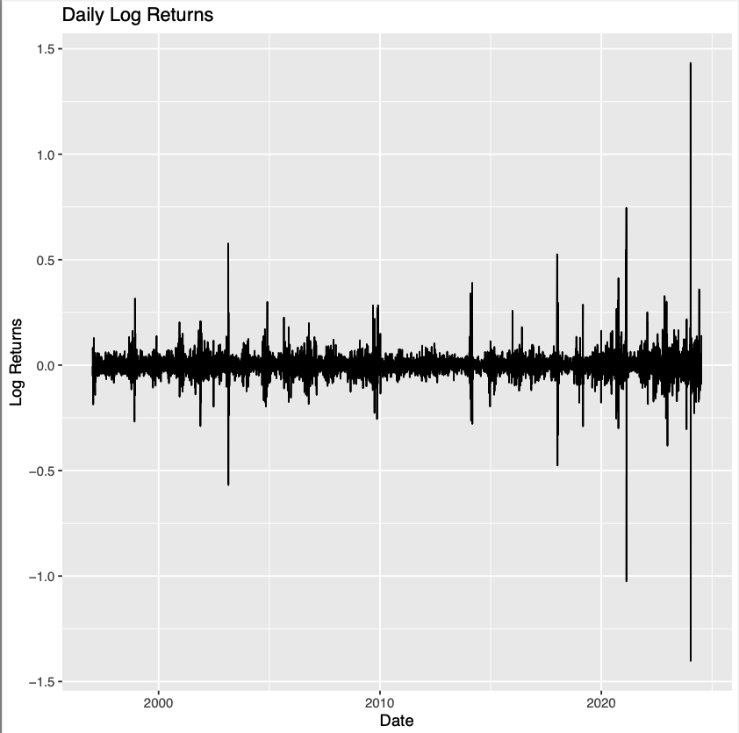

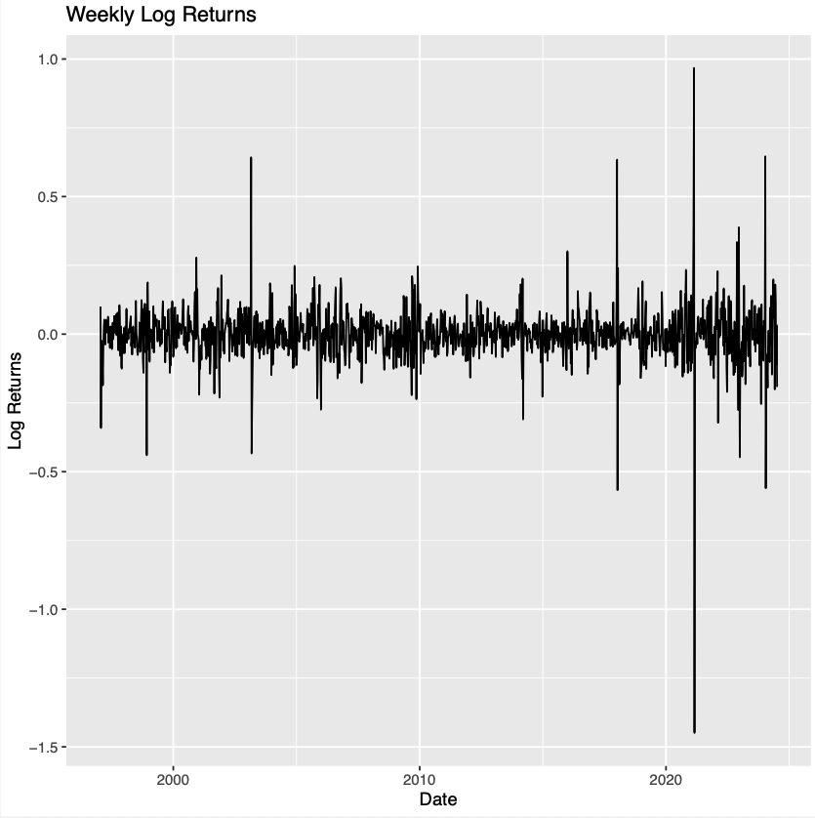

The data shows significant volatility, with frequent positive and negative log returns, indicating considerable fluctuations in the price during the observed period. Additionally, there are stretches of sustained positive or negative log returns, suggesting potential trends in the price.

# Daily Data Summary Statistics Analysis

The summary statistics for the daily data indicate the following:

**Mean**: -0.0066013, suggesting a slight overall decline in the price.

**Standard Deviation (SD)**: 5.827211, indicating high variability in the daily returns.

**Median**: 0, implying that half of the daily returns are below and half are above this value, pointing to a symmetrical distribution around zero.

**Variance**: 0.3395639, further supporting the high variability observed in the daily returns.

# Weekly Data Summary Statistics Analysis

**Mean:** -0.0418701, suggesting a slight overall decline in the price on a weekly basis.

**Standard Deviation (SD):** 9.690919, indicating a high level of variability in the weekly returns.

**Median:** 0, suggesting that half of the weekly returns are below and half are above this value, indicating a symmetrical distribution around zero.

**Variance:** 0.9391391, which confirms the high variability in the weekly returns.

# Augmented Dickey-Fuller Test for Daily Data

The output of the Augmented Dickey-Fuller (ADF) test on the daily log returns indicates the following:

* **Test Statistic (Dickey-Fuller):** -20.803
* **Lag Order:** 19
* **P-Value:** 0.01 (with a warning that the actual p-value is smaller than printed)

Given the low p-value (0.01), the null hypothesis of the test is rejected, which states that the data has a unit root (non-stationary). Therefore, the alternative hypothesis of stationarity is supported. This means that the daily log returns are stationary, showing no long-term trend and having constant statistical properties over time.

# Augmented Dickey-Fuller Test for Weekly Data

The output of the Augmented Dickey-Fuller (ADF) test on the weekly log returns indicates the following:

* **Test Statistic (Dickey-Fuller):** -12.198
* **Lag Order:** 11
* **P-Value:** 0.01 (with a warning that the actual p-value is smaller than printed)

Similar to the daily data, the low p-value (0.01) leads to the rejection of the null hypothesis of a unit root (non-stationarity). Thus, the alternative hypothesis of stationarity is accepted. This suggests that the weekly log returns are also stationary, exhibiting constant statistical properties over time without long-term trends.

# ARCH effects test for Daily Data

The results of the ARCH effects test (Box-Ljung test) on the daily data indicate the following:

* **Test Statistic (X-squared):** 1921.4
* **Degrees of Freedom (df):** 2
* **P-Value:** < 2.2e-16

Given the extremely low p-value, the null hypothesis, which suggests that yyy (the series) is homoscedastic (having constant variance) is rejected. Instead, the alternative hypothesis that yyy is heteroscedastic is accepted. This implies that the daily log returns exhibit changing variance over time, indicating the presence of ARCH effects.

# ARCH effects test for Weekly Data

The results of the ARCH effects test (Box-Ljung test) on the weekly data indicate the following:

* **Test Statistic (X-squared):** 231.11
* **Degrees of Freedom (df):** 2
* **P-Value:** < 2.2e-16

Given the extremely low p-value, the null hypothesis that yyy (the series) is homoscedastic (having constant variance) is rejected. Instead, the alternative hypothesis that yyy is heteroscedastic is accepted. This implies that the weekly log returns also exhibit changing variance over time, indicating the presence of ARCH effects.

# GARCH model analysis for daily Data

### **Model Specification:**

* **Model Type:** GARCH(1,1)
* **Mean Model:** ARFIMA(0,0,0)
* **Conditional Distribution:** Normal

### **Coefficients:**

* **Mu (μ):** -0.00021116 (not statistically significant, p-value = 0.572)
* **Omega (ω):** 0.000040928 (statistically significant, p-value < 2e-16 ***)
* **Alpha1 (α1):** 0.24397 (statistically significant, p-value < 2e-16 ***)
* **Beta1 (β1):** 0.79002 (statistically significant, p-value < 2e-16 ***)

### **Summary Statistics:**

* **Log Likelihood:** 12377.67
* **Normalized Log Likelihood:** 1.789974

### **Error Analysis:**

* **Mu (μ):** Estimate = -0.00021116, Std. Error = 0.0003735, t-value = -0.565, p-value = 0.572 (not significant)
* **Omega (ω):** Estimate = 0.000040928, Std. Error = 0.000006068, t-value = 6.745, p-value = 1.53e-11 (highly significant)
* **Alpha1 (α1):** Estimate = 0.24397, Std. Error = 0.01266, t-value = 19.275, p-value < 2e-16 (highly significant)
* **Beta1 (β1):** Estimate = 0.79002, Std. Error = 0.009794, t-value = 80.661, p-value < 2e-16 (highly significant)

### **Model Convergence:**

The solver encountered a convergence problem, indicating that the optimization did not fully succeed. This could affect the reliability of the parameter estimates.

### **Interpretation:**

* The significant alpha (α1) and beta (β1) coefficients suggest that both the previous day's volatility (α1) and the previous day's conditional variance (β1) significantly contribute to today's conditional variance.
* The large beta (β1) coefficient indicates high persistence in volatility, meaning that shocks to volatility tend to have a prolonged effect.
* The non-significant mu (μ) suggests that the mean return is not significantly different from zero.
* The convergence issue should be addressed to ensure the reliability of the model. Possible solutions include adjusting the model specifications or re-evaluating the data for issues that might affect convergence.

Garch Model Conditional Variance Graph

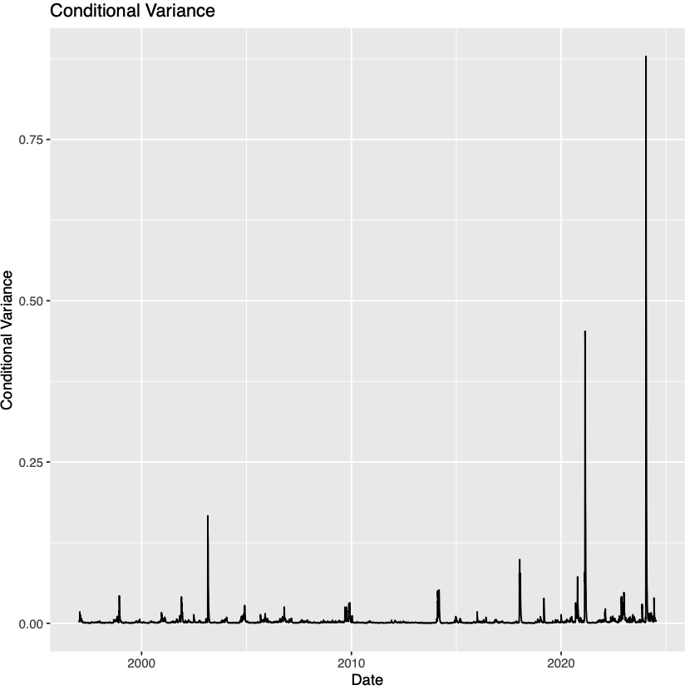

# GARCH model analysis for weekly Data

### **Model Specification:**

* **Model Type:** GARCH(1,1)
* **Mean Model:** ARFIMA(0,0,0)
* **Conditional Distribution:** Normal

### **Coefficients:**

* **Mu (μ):** -0.0015817 (not statistically significant, p-value = 0.345)
* **Omega (ω):** 0.0005408 (statistically significant, p-value < 2e-16 ***)
* **Alpha1 (α1):** 0.3876792 (statistically significant, p-value < 2e-16 ***)
* **Beta1 (β1):** 0.6365906 (statistically significant, p-value < 2e-16 ***)

### **Error Analysis:**

* **Mu (μ):** Estimate = -0.0015817, Std. Error = 0.0016763, t-value = -0.944, p-value = 0.345 (not significant)
* **Omega (ω):** Estimate = 0.0005408, Std. Error = 0.0001333, t-value = 4.057, p-value = 4.97e-05 (highly significant)
* **Alpha1 (α1):** Estimate = 0.3876792, Std. Error = 0.0444386, t-value = 8.724, p-value < 2e-16 (highly significant)
* **Beta1 (β1):** Estimate = 0.6365906, Std. Error = 0.0341400, t-value = 18.646, p-value < 2e-16 (highly significant)

### **Summary Statistics:**

* **Log Likelihood:** 1640.043
* **Normalized Log Likelihood:** 1.144482

### **Optimal Parameters:**

* **Mu (μ):** Estimate = 0.008143, Std. Error = 0.004856, t-value = 1.6768, p-value = 0.093579 (not significant)
* **ArchM:** Estimate = -0.148803, Std. Error = 0.069398, t-value = -2.1442, p-value = 0.032018 (significant)
* **Omega (ω):** Estimate = 0.000597, Std. Error = 0.000144, t-value = 4.1476, p-value = 0.000034 (highly significant)
* **Alpha1 (α1):** Estimate = 0.365831, Std. Error = 0.041098, t-value = 8.9013, p-value < 2e-16 (highly significant)
* **Beta1 (β1):** Estimate = 0.633169, Std. Error = 0.034248, t-value = 18.4875, p-value < 2e-16 (highly significant)

### **Robust Standard Errors:**

* **Mu (μ):** Estimate = 0.008143, Std. Error = 0.005411, t-value = 1.5048, p-value = 0.132378 (not significant)
* **ArchM:** Estimate = -0.148803, Std. Error = 0.078256, t-value = -1.9015, p-value = 0.057238 (not significant)
* **Omega (ω):** Estimate = 0.000597, Std. Error = 0.000390, t-value = 1.5302, p-value = 0.125968 (not significant)
* **Alpha1 (α1):** Estimate = 0.365831, Std. Error = 0.098613, t-value = 3.7098, p-value = 0.000207 (highly significant)
* **Beta1 (β1):** Estimate = 0.633169, Std. Error = 0.113427, t-value = 5.5822, p-value < 2e-16 (highly significant)

### **Information Criteria:**

* **Akaike:** -2.2846
* **Bayes:** -2.2662
* **Shibata:** -2.2846
* **Hannan-Quinn:** -2.2777

### **Diagnostic Tests:**

* **Weighted Ljung-Box Test on Standardized Residuals:**
  + Lag[1]: statistic = 16.32, p-value = 5.355e-05
  + Lag[2*(p+q)+(p+q)-1][2]: statistic = 16.53, p-value = 3.627e-05
  + Lag[4*(p+q)+(p+q)-1][5]: statistic = 18.92, p-value = 3.834e-05
* **Weighted Ljung-Box Test on Standardized Squared Residuals:**
  + Lag[1]: statistic = 0.2145, p-value = 0.6433
  + Lag[2*(p+q)+(p+q)-1][5]: statistic = 0.7870, p-value = 0.9057
  + Lag[4*(p+q)+(p+q)-1][9]: statistic = 1.1313, p-value = 0.9802
* **Weighted ARCH LM Tests:**
  + ARCH Lag[3]: statistic = 0.2606, p-value = 0.6097
  + ARCH Lag[5]: statistic = 0.4818, p-value = 0.8890
  + ARCH Lag[7]: statistic = 0.6840, p-value = 0.9588
* **Nyblom Stability Test:**
  + Joint Statistic: 1.0452
  + Individual Statistics: mu = 0.03790, archm = 0.04779, omega = 0.13766, alpha1 = 0.10718, beta1 = 0.09835
* **Sign Bias Test:**
  + Sign Bias: t-value = 0.0139, prob = 0.9889 (not significant)
  + Negative Sign Bias: t-value = 0.8325, prob = 0.4053 (not significant)
  + Positive Sign Bias: t-value = 1.1504, prob = 0.2502 (not significant)
  + Joint Effect: t-value = 3.2319, prob = 0.3572 (not significant)
* **Adjusted Pearson Goodness-of-Fit Test:**
  + Group 1: statistic = 72.36, p-value = 3.712e-08
  + Group 2: statistic = 80.55, p-value = 9.638e-07
  + Group 3: statistic = 91.27, p-value = 4.478e-06
  + Group 4: statistic = 100.88, p-value = 1.858e-05

### **Interpretation:**

* The significant alpha (α1) and beta (β1) coefficients suggest that both the previous week's volatility (α1) and the previous week's conditional variance (β1) significantly contribute to the current week's conditional variance.
* The large beta (β1) coefficient indicates high persistence in volatility, meaning that shocks to volatility tend to have a prolonged effect.
* The non-significant mu (μ) suggests that the mean return is not significantly different from zero.
* The convergence of the model is successful, and the diagnostic tests support the model fit without significant serial correlation or remaining ARCH effects.

Garch Model Conditional Variance Graph

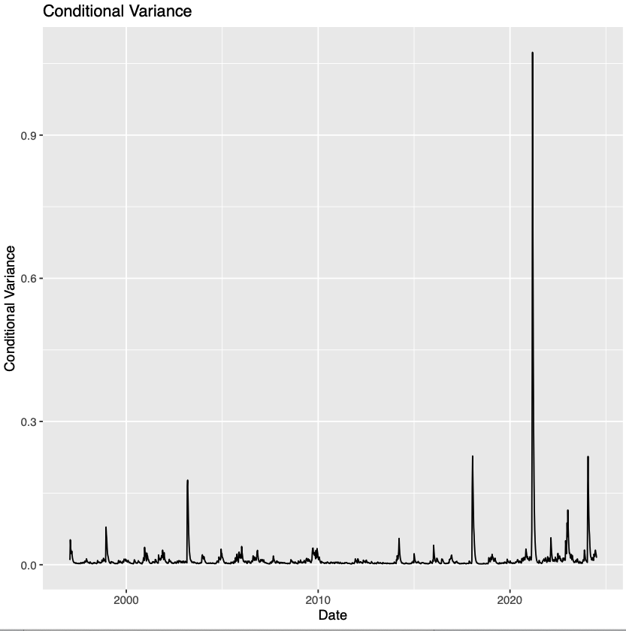

# Garch modeling comparison - Weekly vs Daily

Both daily and weekly data exhibit significant persistence in volatility and ARCH effects, indicating that shocks to volatility have a lasting impact. The models suggest that while daily data shows higher volatility persistence, weekly data provides a more stable estimation with better convergence and fit. Choosing between them would depend on the specific needs of the analysis, such as frequency of decision-making or granularity required for forecasting or risk management purposes.